Jim Morrison
April 29, 2002
The Most Intellectually Significant Essay Ever Written on Franz Kafka’s Die Verwandlung (The Metamorphosis).
The Metamorphosis by Franz Kafka is indeed a very intriguing and challenging short story. It is full of symbolism that provides a unique insight on the intricacies of guilt and alienation. The significance of these elements is debatable however. In order to truly understand The Metamorphosis and thus to truly understand the genius of Franz Kafka one must answer the most difficult question of all; the only question really worth asking; just what in the heck did Gregor turn into anyway? The answer to this question is the key to the entire enigma that is Kafka and The Metamorphosis. To be sure there are other theories that may help one gain an understanding of the basic plot of the story. For instance the three lodgers may be interpreted as an un-holy trinity or the apple in Gregor’s back as a representation of sin and the burden it has placed on the Samsas, but these are just bits of a puzzle lacking the edge pieces. They are nothing more than filler material and without a framework they are nothing. The mystery of Gregor’s classification provides this framework without which The Metamorphosis lacks any semblance of coherence or meaning.
“Ungeheueren Ungeziefer,” monstrous or enormous vermin, this is the description Kafka gives us of Gregor’s new physicality. However, “vermin” is a rather general term used to describe everything from cockroaches to rats and mice but if we read further Kafka gets more specific. “He (Gregor) was lying on his hard, as it were armor-plated, back and when he lifted his head a little he could see his domelike brown belly divided into stiff arched segments on top of which the bed quilt could hardly stay in place and was about to slide off completely. His numerous legs, which were pitifully thin compared to the rest of his bulk, waved helplessly before his eyes.” Already we have a good idea of what he looks like. We know that he is indeed some sort of arthropod by way of his “armor-plated” back and segmented belly. So, a brown arthropod with many legs that are disproportionately small when compared to his overall bulk that sprout from his arched and segmented underside with an “itching place which was surrounded by many small white spots the nature of which he could not understand.” As one might imagine ever this description does not begin to give us a definitive answer as to what exactly Gregor has become. Gregor could be anything from an American Cockroach to a European Earwig to a, well, any number of things, all we’re looking for is a brown arthropod with little legs that come out from underneath and it’s not like there aren’t a lot of those. Let’s look into it a little deeper shall we?
In addition to his general physical description we are given numerous descriptions of Gregor’s behavior that can also give clues to his identity. Of course Gregor lives in his parents’ house so he must be able to live in a dry environment; it may also be assumed that he can tolerate cold weather since the story take place during winter and early spring in Austria. He also has the ability to climb on walls and ceilings but there is no description of his taking flight so there is no necessity for wings though they cannot be ruled out; however any wings would most likely not be very prominent. So Gregor could not logically be a dragonfly. In addition he possesses an affinity for sour milk and other moist and rotting leftovers. As an added bonus we can assume that since Gregor has taken a liking to hiding under the sofa that he is rather thin proportionally and so for instance could not be a cicada or like insect. And from his numerous and painful attempts to open the door to his room we find that Gregor is endowed with mandibles of some size and strength.
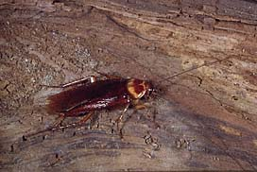
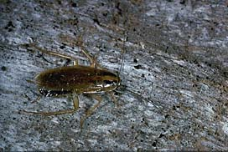
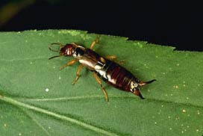
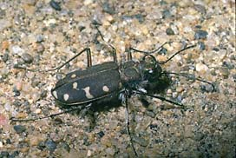
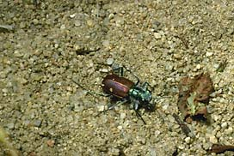
Armed with these facts about Gregor’s appearance and behavior we can begin to make a few guesses as to his identity. There are five different possibilities that we will examine in closer detail (in order of appearance), the German Cockroach, the American Cockroach, the European Earwig, the Oregon Tiger Beetle, and the standard Tiger Beetle.

Almost right away the Tiger Beetles can be eliminated from the running. Despite their resemblance to Kafka’s description of Gregor right down to their massive jaws and spindly legs, their behavior is much different than that of the docile Gregor. While Gregor is content to feast on the family’s garbage and leftovers the Tiger Beetles are predators that catch and devour other insects with their large jaws. Very un-becoming of a traveling salesman don’t you think? It is usually best if one does not devour one’s own customers.
Unfortunately it is not so easy to decide between the last three for all have their resemblances to Gregor as well as their deviations from his description. It has been theorized, even assumed by many that Gregor was a cockroach. In general this is a good theory and not at all unbelievable. Both the German and the American varieties thrive in urban settings and feast on garbage regularly. The American Cockroach also fits Kafka’s description quite well and the German variety can only be faulted for its grayish tint in this regard. However, the American Cockroach cannot possibly be our Gregor because it seems that they are absolutely intolerant of cold temperatures, indeed they are most at home in the mid-80’s Fahrenheit.
German Cockroaches still have few things going for them despite their coloration. The special ability to climb on even the smoothest vertical surfaces lends itself to Kafka’s description of Gregor attaching himself to the painting of a woman on his wall. The problem of color is resolved in that the younger adult ‘roaches are much darker in color that the fully mature variety. Conveniently enough these insect are able to go for two weeks without food and water before they die, which is exactly the amount of time it took Gregor to die after he stopped eating. The clincher perhaps is the foul smelling secretions of the German Cockroach. After all, Grete had to have some reason for flinging open the window each time she entered Gregor’s room, it must have been the smell. Of course the German Cockroach does not posses abnormally large mandibles but they are definitely present and could easily turn a door knob if the creature were the size of a man as in the early stages of Gregor’s metamorphosis. And hey, it’s a German Cockroach, Kafka’s from Austria, you know, near Germany, coincidence…I think not.
As for the earwig it’s completely out of the question due to its freakishly large forceps (which are actually in the back). But we’ve found our winner so why am I still rambling about this earwig loser?
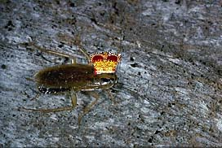
To conclude the most intellectually significant essay ever written on Franz Kafka’s Die Verwandlung (The Metamorphosis), Gregor Samsa turned into a German Cockroach (Blattella germanica). And there you have it, the key to the enigmatic Kafka. You may thank me later. Go now into the world; use your newfound power wisely and always for the sake of good. God help use if this knowledge should be used in any other way.
Our Winner!

http://www.kafka.org/projekt/lebzeit/verwandlung.htm
http://www.kafka.org/projekt/lebzeit/verwandlung.htm
http://www.kafka.org/projekt/lebzeit/verwandlung.htm

